AS91907 - Use complex processes to develop a digital technologies outcome

Documentation.

# Introduction:

Discuss the problem or scenario:

I want to create a simple text-based calories calculator that allows users to input the type of food they have eaten and the quantity and then output the total calorie intake.

**Solution**

List down the possible solutions:

* Create a list or dictionary containing various food items along with their corresponding calorie counts
* During the program's introduction, show the user the available food items and their calorie values
* Calculate the total calories for the entered food item by multiplying the food's calorie count and adding a running total of calories

**Purpose**

What is the purpose of your chosen solution:

The goal of using a list or dictionary of food items with their calorie counts which is to make the process easier for the user. Instead of entering the calorie count for each food item, the program can simply use a list of common foods and their calorie values.

## Implications

What will be the implications of your design?

The accuracy of the calorie calculator depends on the correctness of the data in the list or dictionary

**Progress**

What I have achieved so far is that I learnt the basic programming structure and used it towards my project creating a basic programming calculator that adds up the calories of each serving using the Tkinter extension on Visual studio

**End-user Feedback:**

The feedback that I received was that my GUI V1 wasn’t appealing but could be refined to make a modern type of GUI.

## Test Table:

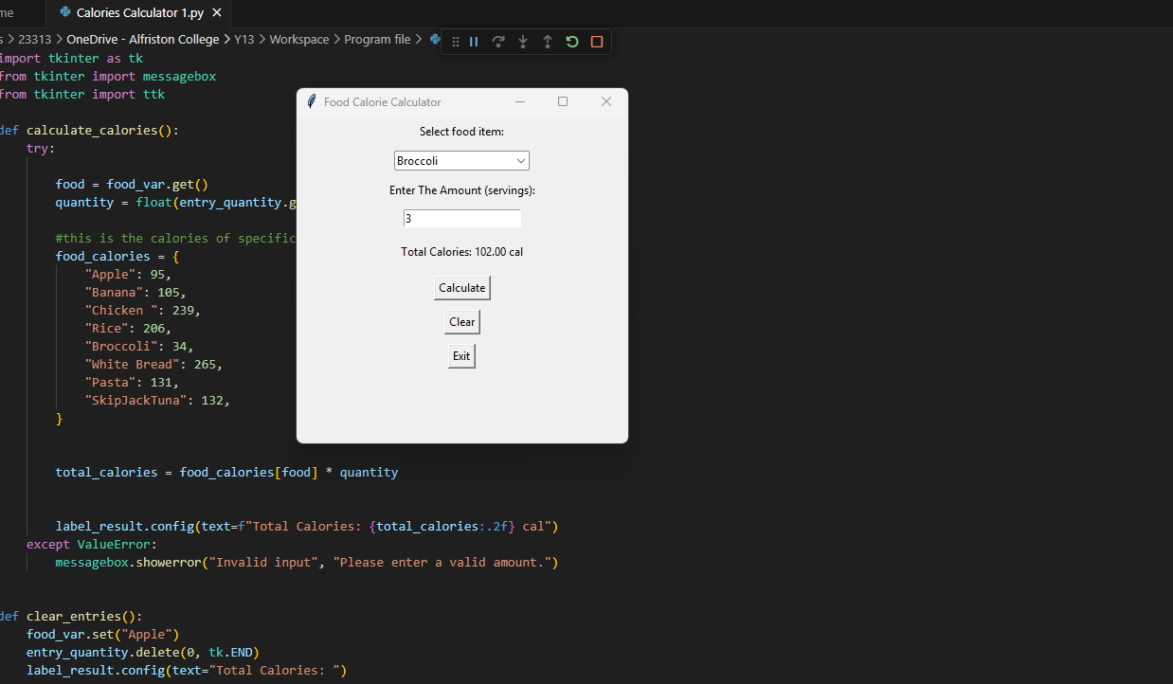

|  |  |  |  |  |
| --- | --- | --- | --- | --- |
|  | Input | Expected Output | Output | Pass/fail |
|  | Apple/2 servings | 190 calories (95x2) | 190 Calories | Pass |
|  | Banana, 1 serving | 105 calories | 105 Calories | Pass |
|  | Chicken breast, 0.5 servings | 82.5 calories | 82.5 calories | Pass |
|  | Pasta/invalid food input | Error or prompt | program crashes | Fail |

## Debug Table:



Minor Error Fixed: It was somewhere in the food selection that didn’t match with the food variable.

(No photo when it happened. Reason: I forgot to snip the photo)

|  |  |  |
| --- | --- | --- |
| Bug description | Cause | fixes |
| Food input not matching the dictionary variable | food names were Uppercase | Used. lower () to normalize input |
| GUI layout was not aligned | tkinter grid misused | updated to use proper grid () placement |
| Program crashed with unknown food input. | no error handling for invalid input | added try/except and input validation or deleted it. |

## A screen shot of a phone AI-generated content may be incorrect.Prototype 1:

For my Prototype 1 design was a simple design that could calculate the number of calories per serving as the image on the right shows that 2 apples have the total amount of 190.00 calories which is accurate to what I researched through google chrome.

## Trello (Project management tool)

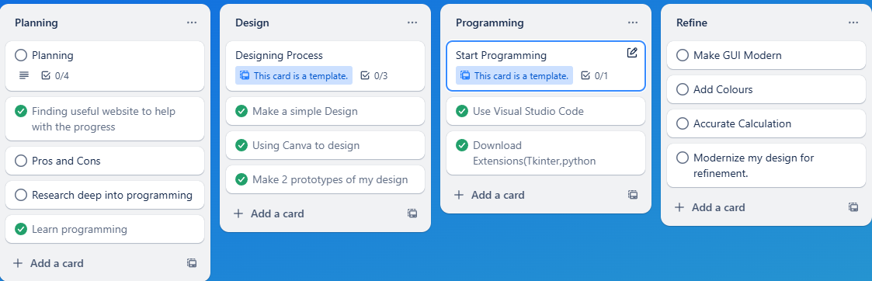This is my management for my project (Food calorie calculator)

This is where most of my planning goes to, as you can see most of my planning is ticked off but still have some missing.

## Stand up

**What have I Achieved so far?**

I have achieved a protype app that is designed and developed

**What is the next step?**

The next step is to modernize my application using CustomTkinter

To give it an appealing look to my GUI, adding more items on the list and maybe a graph rate to show the calories if I feel like it’s helpful, I will also be adding colours into GUI

With accurate calculation of the items. Basically, a whole refinement to my project.

**Any Roadblocks?**